A Brief Introduction to MS Project
References: A. Systems Analysis and Design Methods 7th Edition, Whitten, Bentley, and Dittman, McGraw-Hill
B. Special Edition Using Microsoft Project 98, Tim Pyron, QUE – Macmillan Computer Publishing
C. Project Companion™ http://www.projectlearning.net/project_companion.htm
D. Microsoft Assistance: http://office.microsoft.com/assistance/default.aspx

Purpose
Being able to plan your workload is a valuable skill, needed not only for your studies at college, but also for your future career in industry. Project planning is normally a directly assessed component of the various assignments that you will be required to do as part of your studies. It is also indirectly assessed, as historical records show that student project groups who do not plan their project work, and subsequently follow the plan, often find that they have to rush to get assignments completed on time. This generally results in poor quality work being submitted and a lot of disappointed people when the assignments are marked and returned. Please remember that the emphasis in this course is quality, not quantity!

MS Project is a project planning tool that students are required to use for assignments in CST8143, and subsequent software engineering-related courses. While this tutorial is not intended to cover every aspect of MS Project, the skills gained by successfully completing this tutorial will serve you well in planning future projects both in college, and in industry.

Why Use This Tutorial?
You do not need to use this tutorial. You could instead simply use the Help available in MS Project itself, or buy a good book on MS Project. However, this tutorial seeks to explain and demonstrate some of the facilities that you will find useful for project planning and also suggests some example data that you might be able to use when you take your fifth level software engineering course, where you will commence your real-world projects using the concepts, and practical skill set from this course. I recommend that you work through the tasks of this document and check the results carefully, to see what MS project can do for you, and to ensure that your results match the required solution that is in Appendix A of this tutorial. Don’t worry if you don’t understand exactly WHAT we are doing here – that will be taught in the lecture periods. For now, concentrate on being able to use MS Project, and obtaining the required printout in its exact form.

Let’s Get Started
After starting MS Project 2007, you will be presented with a display similar to the one below, which is the default view of a new project. This default view, called the Gantt chart view is a graphical view that contains a spreadsheet table on the left side, and a bar chart, known as the timescale, on the right side.

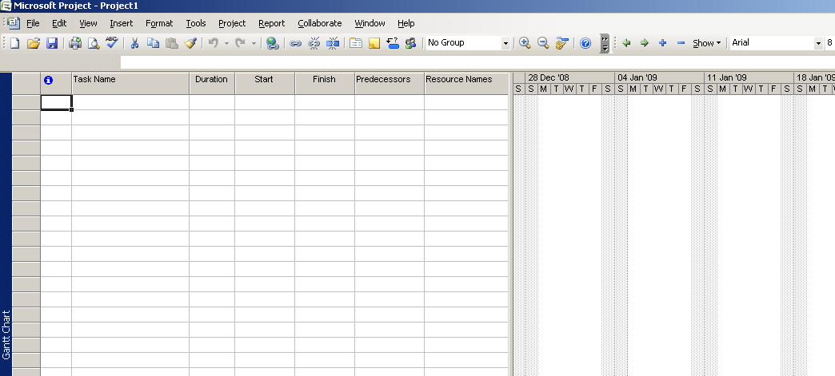
Figure 1: Default View (Winter 2009)

The table displays the task list, the task name, and the duration of each task. There are also additional columns hidden behind the bar chart on the right, which may be viewed with the arrow keys or with the scroll bar beneath the table.

Creating a New Project – Start Date and Base Calendar
To start a new file, choose Blank Project… from under the New heading in the sub-window on the left, which will then display an empty project as shown below and on the left:

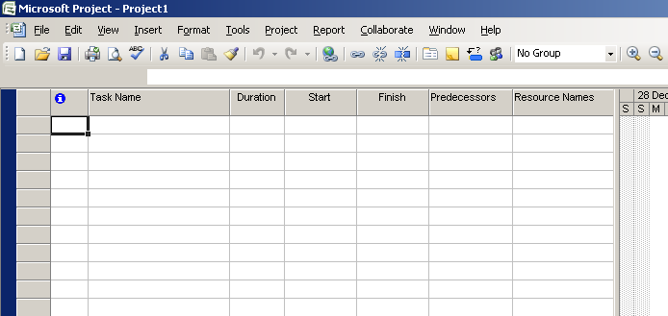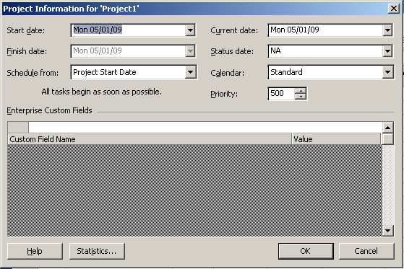
Figure 2: Blank Project and Project Information

We will now use the Project Information dialog box (under the Project menu; Project Information… as shown to the right above) to record basic information about a project – the starting date, and the base calendar to use for scheduling (You may also do this via the “Wizard” from the sub-menu)..

To change the Start Date of the project chose the Start date text box to define a specific date. Note that a calendar similar to the one below will appear, which shows today’s date. Use the arrow keys on the calendar to move between the months, as shown below, and then click on January 5, 2009 to set that date at the Start date for the project.

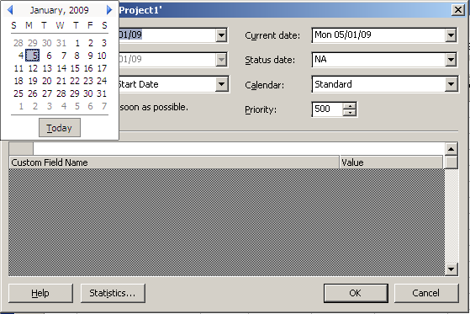
Figure 3: Project Start Date
If you have successfully set the start date of the project to January 5, 2009, you should see a display similar to the following, once you have clicked OK on the Project Information dialog box (NOTE: I have now closed the sub-window).

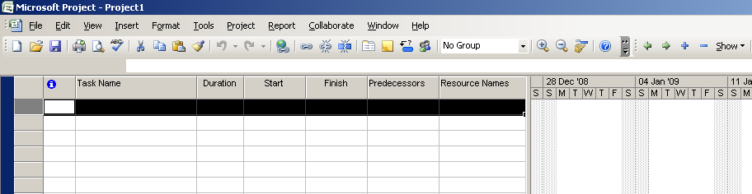
Figure 4: Project with New Start Date

You should also be able to confirm that the Project Start Date
is January 5, 2009 by selecting Project, Project Information on the menu bar.
Our project starts here.
January 5, 2009

Creating a New Project – Project Properties Window
In order to show who created the MS Project file, select File, Properties, and supply the required descriptive information.

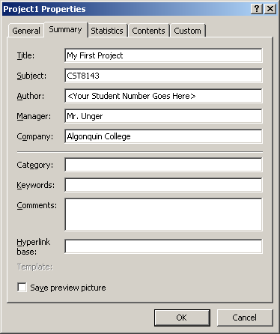
Ensure your student name and number appears here!
Figure 5: Project Properties Window

Creating a New Project – Changing Working and Nonworking Days
By default, MS Project schedules project working days to be Monday to Friday; however, most students do not have the luxury of having weekends away from their studies, so we will edit the standard calendar to reflect that we will be working on weekends as well. Select Tools, Change Working Time, here is an example of the default working and nonworking day setup that will appear:
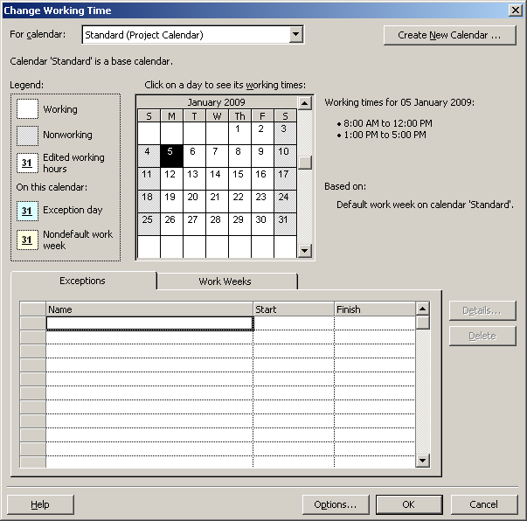
Figure 6: Change Working Time Window

To change the weekends from nonworking to working, select the Work Weeks, tab, press the Details... button and then select Sunday (do the same for Saturday), then select the Set day(s) to these specific working times: radial button. You really should change all the working times from 8:00am to 4:00pm (although a student’s life continues until the wee hours of the morning, we don’t want to have to change all the other information such as associated work day length, work week, etc. to reflect this). NOTE: If after changing the To time to 4pm you do not press ENTER, it will revert back to the previous value.

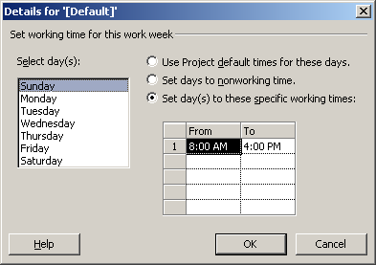
Figure 7: Changing Working Time Procedure

Once you have completed changing the working and nonworking days, then your Gantt Chart display should look like the following. Note the difference between this Gantt Chart display and the version on page one of this tutorial.

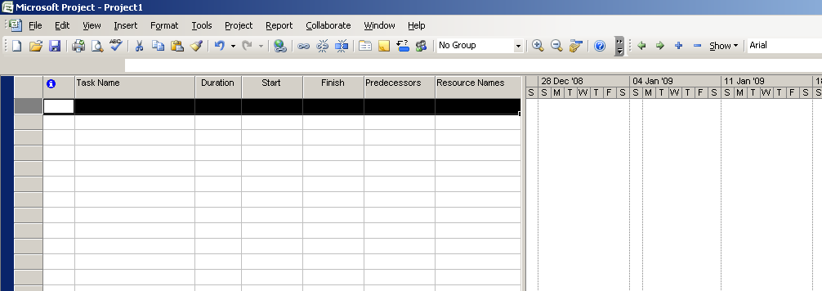
Figure 8: New Project with Working Time Changed

Creating a New Project – Viewing the Columns and Saving a File
Now we wish to setup our project spreadsheet table so that it contains information used in the planning of our project. First, expose the existing information by scrolling the additional fields into view with the arrow keys or with the scroll bar beneath the table. You should see something like that shown in Figure 8 above.

Like any other work, we should occasionally SAVE a project file so that we don’t lose all of our work. To do so, use File,
Save As.

Now let’s add a new column to the spreadsheet view.

Creating a New Project – Adding a New Column
In this tutorial, we will add a new column to the left of “Predecessors.” To accomplish this, click on “Predecessors”, and then right click to bring up the illustrated menu. Select Insert Column, and use the drop down properties of the text boxes to complete the Column Definition dialog box as follows. Once you have completed that, click OK.

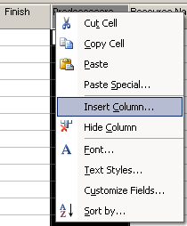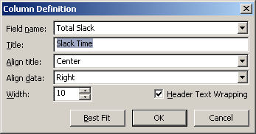
Figure 9: Adding a New Column

You should now see the following newly inserted column, and the project setup is complete.

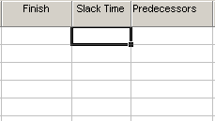
Figure 10: New Slack Time Column

Entering Tasks in the Gantt Chart
Now that we have setup the project information, we will now use MS Project to enter the project tasks. Note that there are several ways to accomplish this with this software product; however, the following is considered to be one of the simpler ways to enter this type of information. If you have previous experience with this product, please feel free to enter information in the manner you are most familiar with.

Type the following Task Name information into the spreadsheet view area, and press <Enter>:
Figure 11: Adding a Task

Did you notice that you only had to type in the Task Name, and that the remaining information auto completed?
This will initially serve as a title (you can choose to manually set it to “bold”), which we will further change to a Summary Task Bar so that we can group like activities together.

Now, type in the next line of text, as follows, and click on the Indent arrow( ).
Your display should look like the following:

Figure 12: Adding a Subtask

Now, change the Duration of “Form Project Teams” to 2 days. Note how the display has changed to the following:

Figure 13: Changing Duration

Thus, whenever an indented entry’s duration is modified, the Summary Task Bar information is also modified. Did you also notice that the ‘?’ is no longer present after the values for the Duration – more on that later.

Creating Task Predecessors

Let’s have our introduction first team meeting – type in the following:

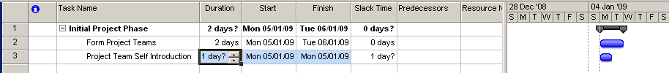
Figure 14: Adding Another Task

But, we can’t have a team meeting until after we have formed the team, so Kickoff Meeting must come after Form Project Teams. Thus, Form Project Teams is a predecessor to Kickoff Meeting. To force this timeline relationship, type in ‘2’ in Predecessors as follows:

Figure 15: Setting Predecessors

Note that the ‘2’ is taken from the task list column.

At this point, type in “Project Team” under the Resource Names column for task 3, and note the display.

Removing the Duration Question (?) Marks
By default, MS Project places a question mark at the time duration in the Duration column of the spreadsheet table. There are at least three ways to eliminate the question. I’ll show you one of them, and let you discover the other two methods. Right click on the cell that has the ? in it to bring up the menu, and then select Task Information to display the Task Information dialog box. Unchecking the Estimated box, and then clicking OK will remove the ? mark in the selected cell.

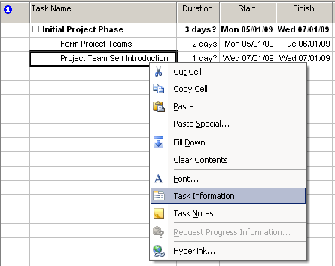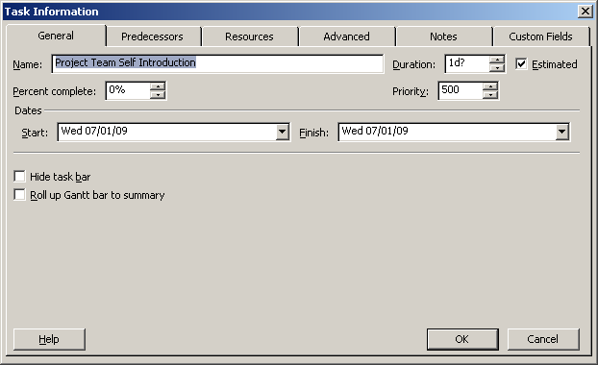
Figure 16: Duration Estimate Removal Procedure

You should now see the following display, with no question marks present in any of the circled cells:

Figure 17: Duration Estimate Removal Result

Adding More Tasks and Their Resources
Continue adding more tasks and their resources from the supplied PDF, left and right indenting and bolding as required until you reach Task ID 10. Now hard-code a date for this task, which changes from semester to semester, based on a relative equation from a specific predecessor. It reads: 2SF+7 days, or: “The predecessor for this task commences at the Start of task ID 2, and this task must Finish on the 7th day after Task ID 2 commences”. (You can find out more about this in Help or in the references, if you wish.)

After you enter the equation, change Task ID 2’s Start Date to January 19, 2009. Project List Promulgated should now read: January 27, 2009 if you have correctly entered the task information (You will also see a warning and a small calendar appear in the “info” column (as shown below). The reasoning behind why this is a “bad” thing will be left for you to discover.

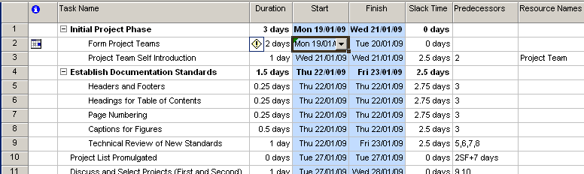
Figure 18: “Bad” Side Effects

Unless otherwise directed, you should not hard-code any dates in MS Project in order to avoid having to manual change and verify the task information should a small change occur. You might want to hard-code the date for this Task ID, change the project start date, and confirm whether or not a hard-coded date changes relative to other changes in a project’s task information. Lastly, change Task ID 2’s Start Date back to what it was before and continue adding more tasks until you have correctly entered all of the task information for this tutorial. Don’t forget to occasionally save your work.

Self Discovery
The tutorial thus far presented should provide you with a head-start on learning the basis of a software scheduling tool like MS Project. You are now left to discover how to use Baselines, Tracking Gantt charts, Network Diagrams and printout MS Project diagrams for your assignment work this semester. While some of this material will be introduced during lecture periods, the supplied references should greatly assist you in your self discovery. Also, don’t forget that your laboratory professor is also a reference – he will be more than willing to point you in the right direction if you regularly come to labs.

Appendix A
CST8143 Software Requirements Specification and Analysis:
MS Project Tutorial

(Required GANTT chart: a separate handout)

